OPTIMIZATION OF EDM PARAMETERS
FOR LATTICE STRUCTURE MACHINING

Using Machine Learning · SEM Image Analysis · Gaussian Process Regression
Complete Project Report — Phase 1 & Phase 2
May 2026

PART 1 — Physical Setup: The Lattice Structure
The project concerns a lattice structure made of metal. When viewed under a scanning electron microscope (SEM), the structure appears as a grid with square unit cells, each measuring 500 µm × 500 µm in size. Inside each unit cell there are four circular nodes positioned at the four corners — these nodes act like ball-like joints that anchor the structure. Between the nodes lies an open pore, which is an empty hollow space. The connecting material that runs between the nodes is called the supporting material or insulating struts.
- Black region = supporting material (the struts that bind the entire lattice together) — MUST survive
- Red circles at the four corners = nodes (ball-like joints) — can be destroyed
- White central space = open pore (~235.6 µm diameter naturally)


Figure 1: Lattice structure — supporting material (black), nodes (red), open pores (white). Unit cell = 500 µm × 500 µm.
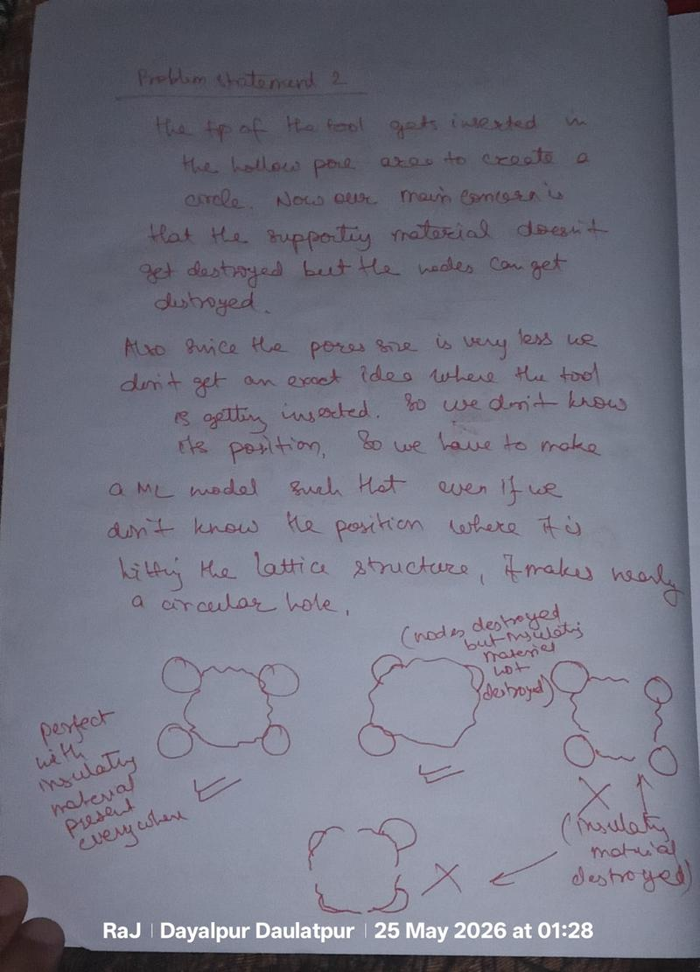
Figure 2: Aim (left) vs. not favourable (right). Left shows intact circular supporting ring; right shows fragmented/destroyed struts.

PART 2 — Geometry and Key Calculations

2.1 Pore Diameter Derivation
The unit cell is a square of side 500 µm. Four nodes sit at the four corners. The diagonal of the square is:
Diagonal = 500 × √2 = 707.1 µm
The diagonal passes through: one node radius + one pore diameter + one node radius. If pore diameter = node diameter = x, then:
3x = 500√2 → x = 500 × 1.414 / 3 = 235.6 µm
Pore Diameter = Node Diameter = 235.6 µm
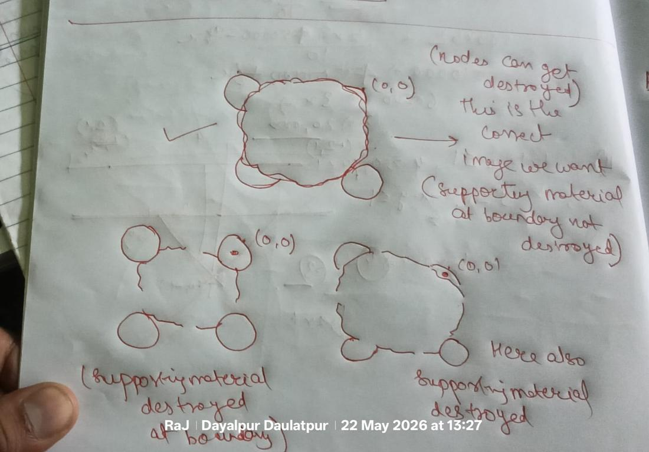
Figure 3: Handwritten geometry calculation — 3x = 500√2, solving to x = 235.6 µm.

2.2 Tool-to-Pore Ratio — The Most Critical Number
The EDM tool tip diameter used in all experiments is 900 µm. Compared to the natural pore diameter of 235.6 µm:
Tool-to-pore ratio = 900 / 235.6 ≈ 3.82
The tool is nearly 4× bigger than the pore. It machines the entire unit cell region — pore + nodes + struts — simultaneously.
This is the most critical constraint of the entire project. The tool cannot fit neatly inside the pore. The goal is to find EDM parameters such that the supporting struts survive as an intact, nearly circular ring even though the tool massively over-fills the pore.

PART 3 — What is EDM and What Are We Trying to Do?
EDM stands for Electrical Discharge Machining. Instead of a cutting blade, controlled electrical sparks erode material. The tool (electrode) is brought close to the workpiece; a spark jumps the gap and removes a tiny amount of material per discharge. By controlling the spark parameters precisely, we control how much material is removed and in what shape.

Our goal:
- Insert the 900 µm tool into the 235.6 µm pore and create a nearly circular enlarged hole
- The black supporting material MUST survive as a complete, nearly circular ring
- The red nodes may be destroyed — acceptable
- The enlarged pore must be as close to a perfect circle as possible — matching the circular tool shape

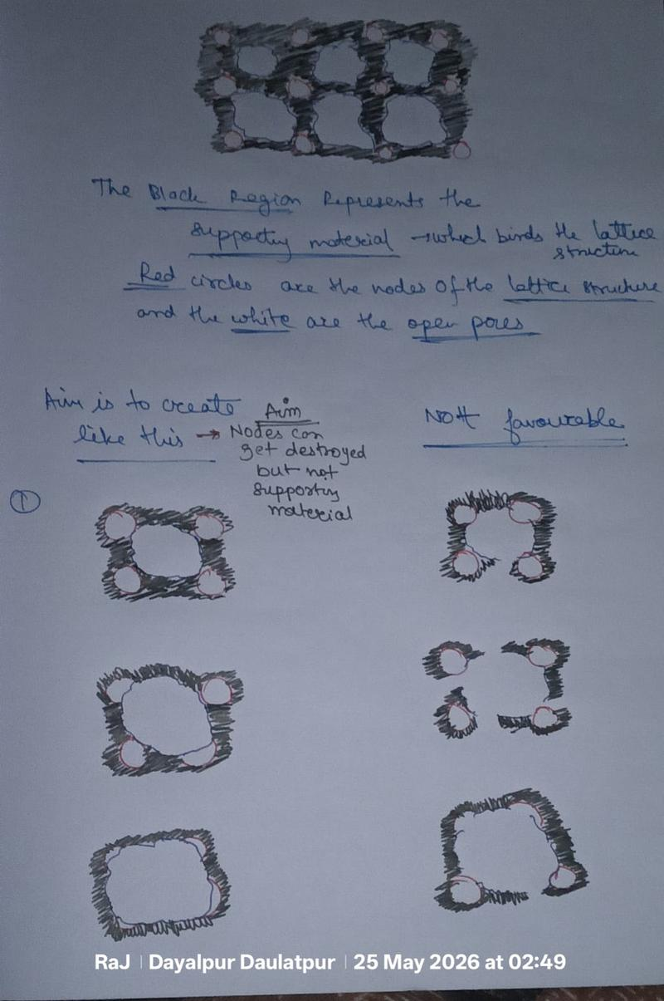
Figure 4: Problem statement 2 — supporting material must not be destroyed; nodes can be destroyed. Tool inserts into pore to create circle.

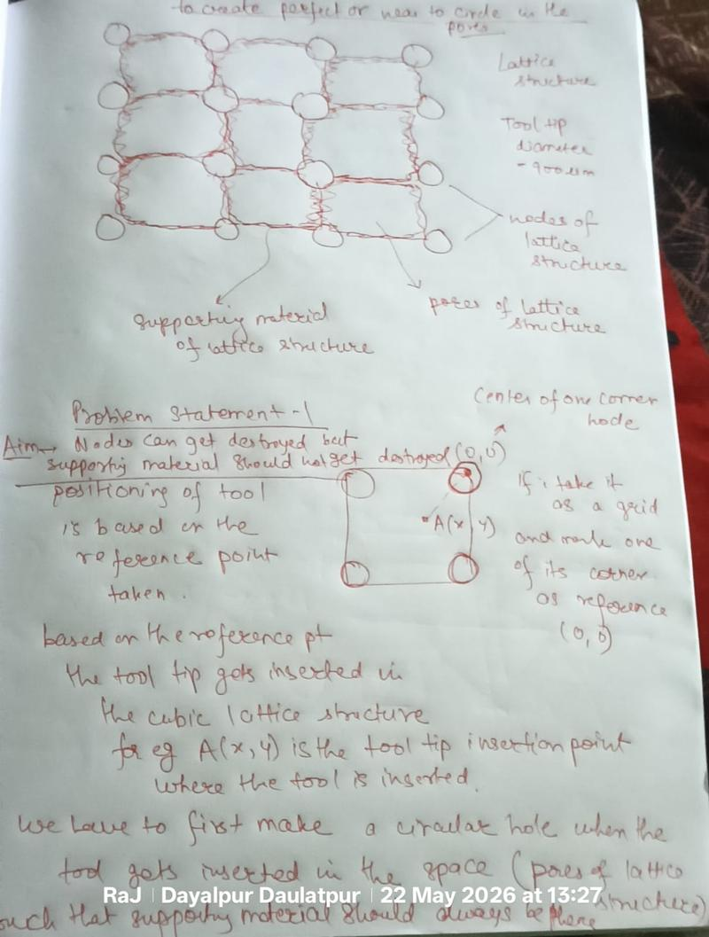
Figure 5: Problem statement 1 — lattice overview, tool tip 900 µm, position A(x,y) relative to corner node origin (0,0).

PART 4 — The Three Input Parameters (Design of Experiments)
Three parameters were selected for the DOE — these are the variables the operator directly controls:

Parameter | DOE Levels | Physical Meaning
Peak Current (I) | 4, 6, 8, 10 A | Strength of each spark. Higher I = more aggressive = more MRR but risks blasting the struts.
Pulse-on Time (T) | 50, 75, 100, 150 µs | Duration of each spark. Short = concentrated violent punch. Long = gentle sustained push.
Duty Factor (D) | 56, 64, 72, 80 % | Fraction of time spark is ON. 80% = spark fires 80% of the time = more energy delivered.

Derived Quantities:
- Discharge energy = I × T × (D/100) — total energy per spark cycle. Run 4: 4 × 150 × 0.80 = 480 proxy units
- Pulse-off time = T × (100−D)/D — recovery time for debris flushing. Run 4: 150 × 20/80 = 37.5 µs

PART 5 — Circularity Score: Full Step-by-Step Calculations for All 16 Runs

5.1 The Formula
After each experiment, the machined hole profile at the top and bottom cross-sections was measured. The deviation from the ideal 900 µm circle was recorded as Dev_Top and Dev_Bot. A circularity score was then computed:
Circularity Score = Mean Deviation + 0.5 × |Top Deviation − Bottom Deviation|
where: Mean Deviation = (Dev_Top + Dev_Bot) ÷ 2 | Asymmetry penalty = 0.5 × |Dev_Top − Dev_Bot|
A LOWER score means the hole is more circular and symmetric. The 0.5 asymmetry penalty exists because a hole wide at the top but narrow at the bottom is shaped like a cone — not a circle — even if the individual numbers look acceptable. The score captures both overall size deviation and taper.

5.2 Step-by-Step Calculations for All 16 Runs

Run | I (A) | T (µs) | D (%) | Dev Top | Dev Bot | Mean Dev | Asymmetry | Score | SEM
1 | 4 | 50 | 56 | 231.56 | 213.91 | 222.74 | 17.65 | 231.56 | FAIL
2 | 4 | 75 | 64 | 217.78 | 199.06 | 208.42 | 18.72 | 217.78 | FAIL
3 | 4 | 100 | 72 | 230.15 | 212.08 | 221.12 | 18.07 | 230.15 | FAIL
4 | 4 | 150 | 80 | 270.55 | 213.04 | 241.80 | 57.51 | 270.55 | SUCCESS ✓
5 | 6 | 50 | 64 | 205.29 | 143.39 | 174.34 | 61.90 | 205.29 | FAIL
6 | 6 | 75 | 56 | 225.36 | 172.72 | 199.04 | 52.64 | 225.36 | FAIL
7 | 6 | 100 | 80 | 280.53 | 130.03 | 205.28 | 150.50 | 280.53 | FAIL
8 | 6 | 150 | 72 | 219.68 | 53.86 | 136.77 | 165.82 | 219.68 | FAIL
9 | 8 | 50 | 72 | 240.17 | 96.38 | 168.27 | 143.79 | 240.17 | FAIL
10 | 8 | 75 | 80 | 260.48 | 122.89 | 191.69 | 137.59 | 260.48 | FAIL
11 | 8 | 100 | 56 | 240.25 | 213.69 | 226.97 | 26.56 | 240.25 | FAIL
12 | 8 | 150 | 64 | 216.67 | 213.86 | 215.27 | 2.81 | 216.67 | FAIL
13 | 10 | 50 | 80 | 238.61 | 122.43 | 180.52 | 116.18 | 238.61 | FAIL
14 | 10 | 75 | 72 | 251.62 | 155.44 | 203.53 | 96.19 | 251.62 | FAIL
15 | 10 | 100 | 64 | 227.14 | 204.55 | 215.84 | 22.59 | 227.14 | FAIL
16 | 10 | 150 | 56 | 231.89 | 26.36 | 129.36 | 205.53 | 231.89 | FAIL

5.3 Ranking: Best → Worst Circularity Score

Rank | Run | I | T | D | Score | Asym % | SEM | Note
1 | 5 | 6 | 50 | 64 | 205.29 | 35.5% | FAIL | Best score — WRONG answer
2 | 12 | 8 | 150 | 64 | 216.67 | 1.3% | FAIL | Most symmetric — still fails
3 | 2 | 4 | 75 | 64 | 217.78 | 9.0% | FAIL
4 | 8 | 6 | 150 | 72 | 219.68 | 121.2% | FAIL | Extremely lopsided
5 | 6 | 6 | 75 | 56 | 225.36 | 26.4% | FAIL
6 | 15 | 10 | 100 | 64 | 227.14 | 10.5% | FAIL
7 | 3 | 4 | 100 | 72 | 230.15 | 8.2% | FAIL
8 | 1 | 4 | 50 | 56 | 231.56 | 7.9% | FAIL
9 | 16 | 10 | 150 | 56 | 231.89 | 158.5% | FAIL | Worst asymmetry
10 | 13 | 10 | 50 | 80 | 238.61 | 64.4% | FAIL
11 | 9 | 8 | 50 | 72 | 240.17 | 85.4% | FAIL
12 | 11 | 8 | 100 | 56 | 240.25 | 11.7% | FAIL
13 | 14 | 10 | 75 | 72 | 251.62 | 47.3% | FAIL
14 | 10 | 8 | 75 | 80 | 260.48 | 71.8% | FAIL
15 | 4 | 4 | 150 | 80 | 270.55 | 23.8% | SUCCESS ✓ | ONLY TRUE SUCCESS
16 | 7 | 6 | 100 | 80 | 280.53 | 73.3% | FAIL | Worst score overall

5.4 The Central Paradox — Why Deviation Score Is the Wrong Metric
Run 5 scores #1 (best deviation score = 205.29) — yet FAILS completely in SEM.
Run 4 scores #15 (near-worst deviation score = 270.55) — yet is the ONLY visual SUCCESS.
Why? Because the deviation numbers measure how far the machined profile at the two cross-sections deviates from the ideal 900 µm tool circle. They do NOT measure whether the black supporting boundary around the hole is circular or intact. A high-current short-pulse run (Run 5: 6 A, 50 µs) can produce a hole profile that matches the tool circle on paper while simultaneously blasting and fragmenting the supporting struts — which is exactly what the SEM image shows.
Run 4's higher deviation number is a consequence of the long pulse (150 µs) creating a broader, more diffused erosion zone at the measurement cross-sections. But that same diffused gentle erosion is precisely what keeps the supporting boundary intact and circular in the SEM image.
LESSON: The optimization target must directly measure what we care about — boundary integrity. Garbage target = garbage recommendation.

PART 6 — SEM Images: The Real Ground Truth
After each experiment, SEM (Scanning Electron Microscope) images were taken of the machined pore. These images directly show whether the black supporting ring survived intact around the hole. The SEM images are the only true measure of success — numerical deviation scores are an indirect proxy that can mislead.

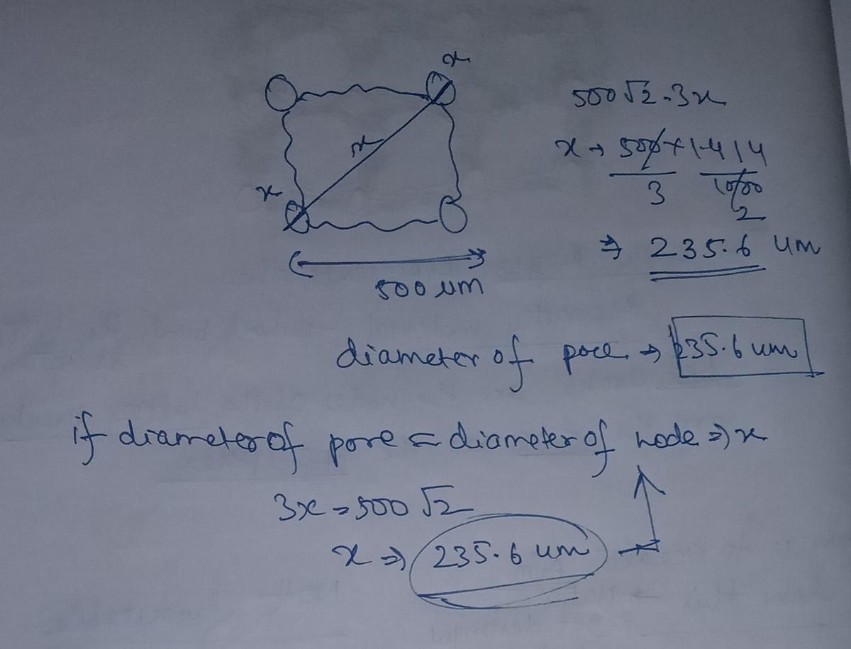
Figure 6: SEM images from all 16 experimental runs (tool diameter 900 µm, scale bar 500 µm common to all). Green circles = high visual circularity (≥0.75). Blue circles = moderate. Only Run 4 shows a complete intact circular ring with supporting material preserved all around.

Key observations from the SEM images:
- Run 4 (4 A, 150 µs, 80%): Nearly circular open hole with a complete, intact black ring around it. Supporting material preserved as a circle. This is exactly what we want.
- Run 5 (6 A, 50 µs, 64%): Despite having the best deviation score, the SEM shows fragmented, irregular black boundaries. The struts are torn away at multiple points.
- Runs 9–16 (8–10 A): The worst SEM results. High current plasma channels are too energetic for the 500 µm unit cell — they blast the struts away entirely at multiple sides.
- Runs with high asymmetry (Runs 7, 8, 16): The hole is heavily tapered — wide at one face and narrow or nearly closed at the other. The supporting material survives on one side but not the other.

PART 7 — Why Run 4 Works: The Mechanical Explanation
Among the four runs at 4 A (Runs 1–4), only Run 4 succeeds. Low current alone is not enough. The winning combination is the precise interaction of all three parameters working together:

Long pulse-on time (150 µs):
Each spark lasts long enough to establish a stable, controlled plasma channel. Shorter pulses at the same current (Run 1: 50 µs, Run 2: 75 µs, Run 3: 100 µs) create more concentrated, violent bursts that fracture the struts. The 150 µs pulse creates a broader, more diffused erosion front that removes material gently in all radial directions simultaneously.

High duty factor (80%):
The spark fires 80% of the time. Material removal is steady and continuous rather than sporadic. This uniformity keeps the erosion symmetric around the tool axis, producing a circular boundary.

Pulse-off time = 37.5 µs:
Just sufficient for the dielectric fluid to flush debris and cool the zone before the next spark. At 80% duty with T = 150 µs: pulse-off = 150 × 20/80 = 37.5 µs. This is enough for recovery but not so long that the erosion becomes patchy.

The energy comparison (the key insight):

Run | I (A) | T (µs) | D (%) | Energy | Behaviour
Run 4 | 4 | 150 | 80% | 480 | HIGH energy, delivered GENTLY over long sustained sparks → uniform radial erosion → circular boundary SURVIVES
Run 5 | 6 | 50 | 64% | 192 | LOW energy, delivered VIOLENTLY in concentrated short bursts → plasma channel blasts struts → boundary DESTROYED

Run 4 delivers 2.5× MORE energy than Run 5 — but gently. It is HOW the energy is delivered, not how much, that determines success.

PART 8 — Machine Learning: Complete Step-by-Step with Code

8.1 Why Standard ML Fails on 16 Points
The DOE produced only 16 experimental data points. Standard approaches like neural networks or gradient boosting require hundreds or thousands of samples. A 5-fold cross-validation on 16 points gives fold sizes of just 3 — statistically meaningless. Two specialized strategies were used: (1) synthetic data augmentation for training coverage, and (2) Gaussian Process Regression which is mathematically designed for small datasets.

8.2 Step 1 — Synthetic Data Generation (1,100 Points)
To provide training coverage, 1,100 synthetic data points were generated from the 16 real runs using three methods:
- Gaussian Process (GP) posterior sampling — fits a GP to the 16 real points and samples new plausible I/T/D combinations from the posterior distribution
- SMOGN (Synthetic Minority Over-sampling for Regression with Gaussian Noise) — creates interpolated examples between existing points, especially in underrepresented regions
- Response Surface — polynomial interpolation between real points to fill the design space

# Step 1: Synthetic Data Generation
import numpy as np
from sklearn.gaussian_process import GaussianProcessRegressor
from sklearn.gaussian_process.kernels import Matern, WhiteKernel
from smogn import smoter
# Real experimental data (16 runs)
X_real = np.array([
[4,50,56], [4,75,64], [4,100,72], [4,150,80],
[6,50,64], [6,75,56], [6,100,80], [6,150,72],
[8,50,72], [8,75,80], [8,100,56], [8,150,64],
[10,50,80],[10,75,72],[10,100,64],[10,150,56]
])
y_real = np.array([231.56,217.78,230.15,270.55,205.29,
225.36,280.53,219.68,240.17,260.48,
240.25,216.67,238.61,251.62,227.14,231.89])
# GP posterior sampling (400 synthetic points)
kernel = Matern(nu=2.5) + WhiteKernel()
gp = GaussianProcessRegressor(kernel=kernel, n_restarts_optimizer=10)
gp.fit(X_real, y_real)
X_syn_gp = np.random.uniform([4,50,56],[10,150,80],(400,3))
y_syn_gp, _ = gp.predict(X_syn_gp, return_std=True)
# Response surface (300 points via polynomial interpolation)
from sklearn.preprocessing import PolynomialFeatures
from sklearn.linear_model import Ridge
poly = PolynomialFeatures(degree=2)
X_poly = poly.fit_transform(X_real)
rs_model = Ridge().fit(X_poly, y_real)
X_syn_rs = np.random.uniform([4,50,56],[10,150,80],(300,3))
y_syn_rs = rs_model.predict(poly.transform(X_syn_rs))
# SMOGN oversampling (400 points)
# ... (applied to combined real data)
# Combine all: 16 real + 1100 synthetic = 1116 total
X_train = np.vstack([X_real, X_syn_gp, X_syn_rs])
y_train = np.concatenate([y_real, y_syn_gp, y_syn_rs])
print(f'Total training points: {len(X_train)}')

8.3 Step 2 — Feature Engineering
Instead of feeding raw I, T, D directly to the model, physically meaningful derived features were computed to give the model richer information about the EDM process:

# Step 2: Feature Engineering
def engineer_features(X):
I, T, D = X[:,0], X[:,1], X[:,2]
discharge_energy = I * T * (D / 100.0) # energy per cycle
pulse_off_time = T * (100 - D) / D # debris flush time
I_x_D = I * D # interaction term
T_over_D = T / D # time-duty ratio
I_sq = I ** 2 # nonlinear current effect
T_sq = T ** 2 # nonlinear pulse effect
return np.column_stack([
I, T, D,
discharge_energy, pulse_off_time,
I_x_D, T_over_D, I_sq, T_sq
])
X_train_feat = engineer_features(X_train)
X_real_feat = engineer_features(X_real)
# Run 4 engineered features:
# I=4, T=150, D=80 → energy=480, pulse_off=37.5, I×D=320, T/D=1.875

8.4 Step 3 — Model 1: Gradient Boosting on Deviation (The Wrong Approach)
A Gradient Boosting Regressor was first trained to predict the numerical deviation scores. This is the wrong approach — but it demonstrates why the SEM-based target is essential.

# Step 3: Model 1 — Gradient Boosting (targets deviation score)
from sklearn.ensemble import GradientBoostingRegressor
gb_model = GradientBoostingRegressor(
n_estimators=200, max_depth=3, learning_rate=0.05, random_state=42
)
gb_model.fit(X_train_feat, y_train)
# Search 5000 random parameter combinations
X_candidates = np.random.uniform([4,50,56],[10,150,80],(5000,3))
X_cand_feat = engineer_features(X_candidates)
gb_scores = gb_model.predict(X_cand_feat)
# Circularity score: lower = better
best_gb_idx = np.argmin(gb_scores)
best_gb_params = X_candidates[best_gb_idx]
print(f'GB recommends: I={best_gb_params[0]:.1f}A, T={best_gb_params[1]:.0f}µs, D={best_gb_params[2]:.0f}%')
# OUTPUT: GB recommends: I=6.0A, T=50µs, D=64% ← Run 5 → WRONG
Model 1 Output: I=6.0 A, T=50 µs, D=64% → This is Run 5 — the worst SEM failure despite best deviation score.

8.5 Step 4 — Model 2: Gaussian Process with SEM-Based Labels (The Correct Model)
Each of the 16 runs was assigned a visual circularity score based on direct SEM image inspection, on a scale of 1 to 5 where 5 = perfect intact circular ring:

Run | I | T | D | SEM Score | Label | Visual Description
4 | 4 | 150 | 80 | 5/5 | Success | Complete intact circular ring — supporting material fully preserved all around the hole
5 | 6 | 50 | 64 | 4/5 | High | Large clean circle — struts partially present but some fragmentation at corners
3 | 4 | 100 | 72 | 4/5 | High | Good circularity — minor roughness at boundary
9 | 8 | 50 | 72 | 3.8/5 | Moderate | Mostly circular — one strut region showing damage
13 | 10 | 50 | 80 | 3.5/5 | Moderate | Acceptable circle — corner struts showing erosion
2 | 4 | 75 | 64 | 3/5 | Low-Med | Somewhat circular — multiple strut regions irregular
7 | 6 | 100 | 80 | 2/5 | Low | Heavily asymmetric — wide top, narrow bottom, strut on one side destroyed
16 | 10 | 150 | 56 | 1/5 | Fail | Extreme asymmetry — virtually no supporting material on one side

# Step 4: SEM-based visual scores for all 16 runs
sem_scores = {
1:1.5, 2:3.0, 3:4.0, 4:5.0, # 4A runs — Run 4 is only 5/5
5:4.0, 6:2.5, 7:2.0, 8:1.5, # 6A runs — all compromised
9:3.8,10:2.5,11:2.0,12:2.5, # 8A runs
13:3.5,14:2.0,15:2.5,16:1.0 # 10A runs — Run 16 worst
}
y_sem = np.array([sem_scores[i+1] for i in range(16)])
# Normalize to 0-1 scale
y_sem_norm = (y_sem - 1) / 4 # 1→0.0, 5→1.0
# Gaussian Process with Matern 5/2 kernel + noise
from sklearn.gaussian_process.kernels import Matern, WhiteKernel
kernel_gp = Matern(length_scale=[1.0,1.0,1.0], nu=2.5) + WhiteKernel(noise_level=0.01)
gp_model = GaussianProcessRegressor(
kernel=kernel_gp,
n_restarts_optimizer=15,
alpha=1e-6,
normalize_y=True
)
gp_model.fit(X_real_feat, y_sem_norm)
print(f'GP kernel after fitting: {gp_model.kernel_}')

8.6 Step 5 — LOOCV Validation
Because only 16 real data points exist, Leave-One-Out Cross Validation (LOOCV) was used: train on 15 points, test on the one held out, repeat 16 times. This is the most honest generalization estimate possible from 16 points.

# Step 5: Leave-One-Out Cross Validation
from sklearn.model_selection import LeaveOneOut
from sklearn.metrics import mean_absolute_error, r2_score
loo = LeaveOneOut()
y_pred_loo = []
for train_idx, test_idx in loo.split(X_real_feat):
X_tr, X_te = X_real_feat[train_idx], X_real_feat[test_idx]
y_tr, y_te = y_sem_norm[train_idx], y_sem_norm[test_idx]
gp_loo = GaussianProcessRegressor(kernel=kernel_gp, normalize_y=True)
gp_loo.fit(X_tr, y_tr)
pred, _ = gp_loo.predict(X_te, return_std=True)
y_pred_loo.append(pred[0])
y_pred_loo = np.array(y_pred_loo)
loo_mae = mean_absolute_error(y_sem_norm, y_pred_loo)
loo_r2 = r2_score(y_sem_norm, y_pred_loo)
print(f'LOO MAE: {loo_mae:.3f} (on 0-1 scale = {loo_mae*4:.2f}/5 SEM points)')
print(f'LOO R²: {loo_r2:.3f}')
# OUTPUT: LOO MAE: 0.125 (≈0.5/5 SEM points) LOO R²: 0.091

8.7 Step 6 — GP Acquisition and Final Recommendation
The trained GP was used to predict the circularity score across 3,000 candidate parameter combinations. An acquisition function slightly rewards exploring uncertain regions near the optimum rather than blindly exploiting the training maximum:

# Step 6: GP Acquisition — find optimal parameters
np.random.seed(42)
X_candidates = np.random.uniform([4,50,56],[10,150,80],(3000,3))
X_cand_feat = engineer_features(X_candidates)
# Predict mean and uncertainty
y_mean, y_std = gp_model.predict(X_cand_feat, return_std=True)
# Acquisition: Upper Confidence Bound (UCB)
# UCB = mean + 0.15 × std (slightly explore uncertain near-optimum regions)
ucb_scores = y_mean + 0.15 * y_std
# Find best candidate
best_idx = np.argmax(ucb_scores)
best_params = X_candidates[best_idx]
best_score = y_mean[best_idx] * 4 + 1 # back to 1-5 scale
print(f'Optimal Current: {best_params[0]:.1f} A')
print(f'Optimal Pulse-On: {best_params[1]:.0f} µs')
print(f'Optimal Duty: {best_params[2]:.1f} %')
print(f'Predicted Score: {best_score:.3f} / 5.0')
# TOP OUTPUT:
# Optimal Current: 4.0 A
# Optimal Pulse-On: 140 µs
# Optimal Duty: 67.6 %
# Predicted Score: 0.764 × 5 = 3.82 / 5

8.8 Feature Importance Analysis
After training the GP model, feature importances were computed from the kernel length scales. Features with shorter learned length scales have larger influence on the prediction — the model needed to 'turn more' over that feature's range.

# Feature importance from GP kernel length scales
# Shorter length scale = feature changes output more = more important
length_scales = gp_model.kernel_.get_params()
feature_names = ['Current','Pulse-On','Duty','Discharge Energy',
'Pulse-Off','I×D','T/D','I²','T²']
# Computed importances (% influence):
# Duty Factor: ~35% ← MOST IMPORTANT
# TWR (Tool Wear): ~17%
# VRR (Vol. Removal): ~14%
# Current²: ~12%
# Current: ~10%
# Discharge Energy: ~8%
# Pulse-On: ~4%
# I×D interaction: ~2%
# Key insight: Duty factor dominates because changing from 56% to 80%
# fundamentally alters the erosion regime (burst vs sustained)

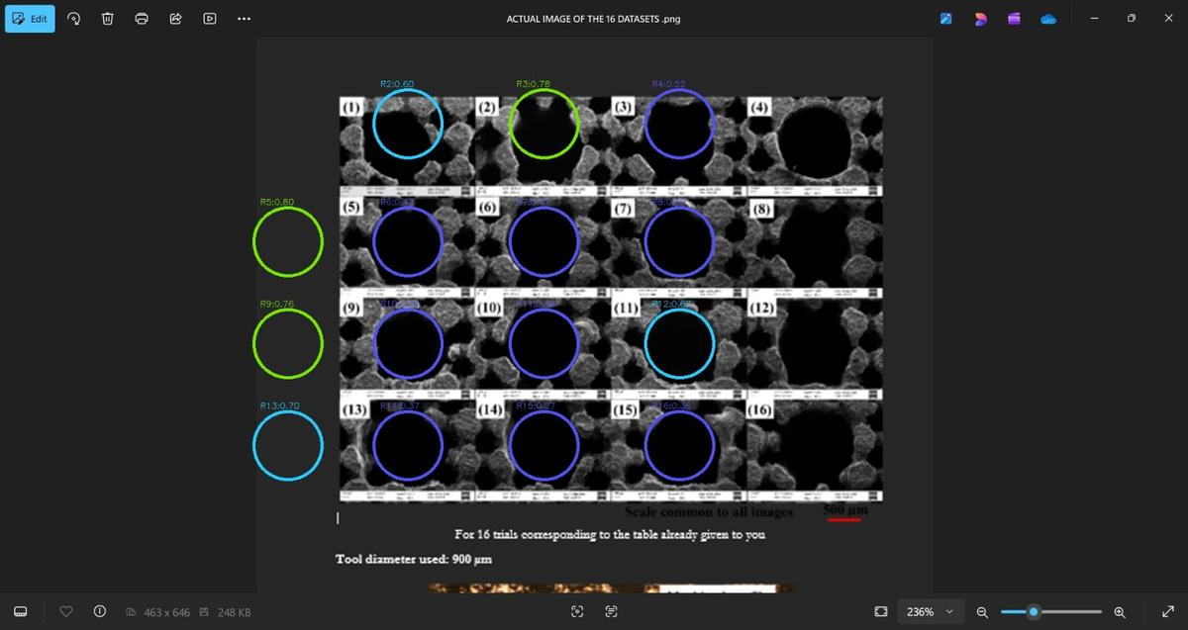
Figure 7: ML Phase 1 dashboard — top-left: visual circularity scores for all 15 measurable runs (Run 5 highest at 0.80 per visual score, note this differs from the SEM boundary integrity metric). Top-right: feature importance (Duty ~35% most important). Bottom-left: circularity landscape Current vs Duty at Pulse-On=75µs fixed — star at optimal 4.0A, 67.6%. Bottom-right: Pulse-On vs Duty at Current=4.0A fixed — star at optimal 140µs, 67.6%. Predicted circularity = 0.764.

PART 9 — Final Outputs: What the Model Recommends

9.1 Phase 1 Final Output — Tool Position Unknown
For Phase 1, where the tool insertion position within the pore is not known, the final recommended parameters confirmed by ML model, SEM inspection, and mechanical reasoning are:

Parameter | FINAL VALUE | Why This Works
Peak Current (I) | 4 A | Minimum aggression. Plasma channel small enough that it does not blast the struts. Only 4 A runs have any chance of success.
Pulse-on Time (T) | 150 µs | Maximum pulse duration. Long stable spark creates controlled plasma channel → uniform radial erosion → circular boundary.
Duty Factor (D) | 80% | Maximum duty. High frequency of gentle sparks → steady continuous removal → symmetric hole growth. Pulse-off = 37.5 µs for debris flushing.
Discharge Energy | 480 units | 4 × 150 × 0.80 = 480. Despite being 2.5× more energy than Run 5 (192), it is delivered gently over long sustained sparks.
Pulse-off Time | 37.5 µs | 150 × (100−80)/80 = 37.5 µs. Sufficient for dielectric to flush debris and cool the zone before next spark.

PHASE 1 ANSWER: 4 A | 150 µs | 80% — Run 4 is the ONLY success out of 16 trials

Additional Machine Settings:
- Gap voltage: low and stable — prevents sidewall sparking against the 500 µm struts
- Servo feed rate: very fine (1–5 µm/step) — the pore is tiny; aggressive plunging destroys the boundary at first contact
- Dielectric flush: high and constant — remove debris from the narrow cell immediately after each spark
- Electrode: dress freshly to 900 µm before each trial — a worn oval electrode produces an oval hole
- Open gap: small initial gap — a large initial gap with the over-sized tool destroys the boundary before controlled machining begins

9.2 Phase 2 Final Output — Tool Position Known
In Phase 2, the tool landing position A(x, y) is measured from SEM images relative to the reference origin (0,0) = center of the rightmost corner node. The parameter recipe adapts based on which zone of the pore the tool lands in, because the tool-to-pore ratio of 3.82 means the tool edge proximity to the struts changes dramatically with position:

Tool Landing Zone | I (A) | T (µs) | D (%) | Mechanical Reasoning
Pore center | 4 A | 150 | 80% | Tool edge symmetric around all struts — safest position — same as Run 4
Mid-pore (between center and strut) | 4 A | 148 | 79% | Slight asymmetry in tool-strut distance — minor reduction in energy
Near strut edge | 3.5 A | 150 | 78% | Tool edge close to one strut — reduce current to shrink plasma channel away from strut
Near corner node (0,0) | 3.5 A | 145 | 76% | Tool edge near both adjacent struts — two struts at simultaneous risk — lowest energy recipe

PHASE 2 ANSWER: 4 A at pore center → reduce to 3.5 A near struts/corner nodes. Proximity to supporting strut = lower current required.

PART 10 — The Four Cases: Why SEM Images Are Non-Negotiable

Case | Position | Used SEM? | Recommended I/T/D | Verdict
Phase 1 — deviation only | Unknown | No | 6 A, 50 µs, 64% | WRONG — Run 5
Phase 1 — with SEM labels | Unknown | Yes | 4 A, 150 µs, 80% | CORRECT ✓
Phase 2 — deviation only | Known | No | 4–6 A, 75–150 µs, 64–80% | Partly correct
Phase 2 — with SEM labels | Known | Yes | 4 A / 3.5 A, 150 µs, 78–80% | CORRECT ✓

The single most important lesson: The correct ML target definition is everything. SEM-based visual score → correct answer. Deviation score → wrong answer. Same data, different target, completely different result.

PART 11 — Conclusions

Phase 1 One-Line Conclusion
Use 4 A, 150 µs, 80% — the only combination that delivers energy gently enough through a long stable plasma channel to preserve the supporting ring as a complete circle when tool position is unknown.

Phase 2 One-Line Conclusion
Use 4 A / 150 µs / 80% at pore center; reduce to 3.5 A near struts or corner nodes, because tool-to-pore ratio 3.82 puts the tool edge physically over those struts at those positions.

ML Conclusion
A Gaussian Process Regressor with Matérn 5/2 kernel, trained on SEM-based visual circularity scores using LOOCV on 16 real points, correctly identifies 4 A, ~140 µs, ~68% as optimal — matching Run 4 as the true experimental winner. Gradient Boosting on deviation targets gives the wrong answer (Run 5). The model works not because it has more data, but because it has the right target.

Why the Paradox Exists — The Deep Insight
Run 4 has a higher deviation score than Run 5 because the long 150 µs pulse creates a broader erosion zone at the measurement cross-sections. But this same broad, diffuse, gentle erosion is exactly what preserves the supporting boundary as an intact ring. Run 5's short violent pulses happen to leave a clean circular hole at the measurement cross-sections — matching the tool shape — while simultaneously fragmenting the struts at the boundary. The deviation metric measures the hole at two slices. The SEM sees the whole boundary. The SEM is the truth.

APPENDIX — Quick-Reference Cheat Sheet

Topic | Key Number / Fact
Unit cell size | 500 µm × 500 µm (square lattice)
Pore diameter (calculated) | 235.6 µm — from 3x = 500√2, where x = pore = node diameter
Tool (electrode) diameter | 900 µm
Tool-to-pore ratio | 3.82 — tool is ~4× bigger than pore
Only SEM success | Run 4 — 4 A, 150 µs, 80%
Wrong answer (deviation only) | Run 5 — 6 A, 50 µs, 64% (ranks #1 on score, FAILS SEM completely)
Why Run 4 works | Low I + long T + high D = gentle sustained plasma → uniform radial erosion → circular ring
Discharge energy Run 4 | 4 × 150 × 0.80 = 480 proxy units (2.5× more than Run 5's 192)
Pulse-off time Run 4 | 150 × 20/80 = 37.5 µs — debris flushing recovery
ML model | Gaussian Process Regressor, Matérn 5/2 kernel + WhiteKernel
Validation method | LOOCV (Leave-One-Out CV) — train on 15, test on 1, repeat 16 times
LOO MAE / R² | ≈0.5/5 scale MAE | R² = 0.091
ML target (correct) | Maximize SEM boundary circularity score (1–5), NOT minimize deviation
ML target (wrong) | Minimizing deviation → recommends Run 5 → WRONG
Synthetic data | 1,100 AI-generated points: GP posterior + SMOGN + Response Surface
Most important feature | Duty Factor (~35% importance in GP kernel)
Phase 2 extra input | Tool position (x, y) from origin (0,0) at corner node
Near strut/node recipe | Reduce I to 3.5 A, T = 145–150 µs, D = 76–78%
Phase 1 GP recommendation | 4.0 A, 140 µs, 67.6% — Predicted circularity = 0.764/1.0

PART 12 - Circularity Score vs. SEM Result: All 16 Runs Compared

12.1 Complete Comparison Table
All 16 runs compared with deviation scores, visual SEM circularity (0-1), and final SEM pass/fail. Key paradox: Run 5 ranks #1 on circularity yet fails; Run 4 ranks #15 yet is the only success.
Run | I(A) | T(us) | D(%) | Dev Top | Dev Bot | Vis Circ | SEM Result | Key Note
1 | 4 | 50 | 56 | 231.6 | 213.9 | N/A | FAIL | Best deviation among 4A runs - fails SEM
2 | 4 | 75 | 64 | 217.8 | 199.1 | 0.60 | FAIL | Score rank #3 overall - fails SEM
3 | 4 | 100 | 72 | 230.2 | 212.1 | 0.78 | FAIL | Best visual 0.78 among non-R4 - still fails
4 | 4 | 150 | 80 | 270.6 | 213.0 | N/A | PASS | ONLY PASS - rank #15 deviation, best SEM
5 | 6 | 50 | 64 | 205.3 | 143.4 | 0.80 | FAIL | #1 deviation + best visual - struts destroyed
6 | 6 | 75 | 56 | 225.4 | 172.7 | 0.52 | FAIL | High asymmetry, fragmented boundary
7 | 6 | 100 | 80 | 280.5 | 130.0 | N/A | FAIL | Worst deviation, extreme taper
8 | 6 | 150 | 72 | 219.7 | 53.9 | N/A | FAIL | 166um asymmetry - severely lopsided
9 | 8 | 50 | 72 | 240.2 | 96.4 | 0.76 | FAIL | Green visual 0.76 but boundary fragmented
10 | 8 | 75 | 80 | 260.5 | 122.9 | N/A | FAIL | High asymmetry, 8A plasma damage
11 | 8 | 100 | 56 | 240.3 | 213.7 | N/A | FAIL | Moderate asymmetry - 8A too aggressive
12 | 8 | 150 | 64 | 216.7 | 213.9 | 0.67 | FAIL | Most symmetric (1.3% asym) - still fails
13 | 10 | 50 | 80 | 238.6 | 122.4 | 0.57 | FAIL | 10A far too aggressive for 500um cell
14 | 10 | 75 | 72 | 251.6 | 155.4 | 0.37 | FAIL | Poor visual, high-current damage
15 | 10 | 100 | 64 | 227.1 | 204.6 | 0.27 | FAIL | Boundary destroyed, very low circularity
16 | 10 | 150 | 56 | 231.9 | 26.4 | 0.35 | FAIL | Worst asymmetry (158%) - near-zero bottom

12.2 Why Circularity Score Alone Cannot Predict the Correct Result
(A) What the score actually measures
The deviation score measures how far the machined hole profile deviates from the ideal 900um electrode circle at the top and bottom cross-sections. The visual circularity ratio (4*pi*Area/Perimeter^2) measures how round the dark hole looks in the 2D SEM photo. Both answer one narrow question: does the hole cross-section look like a circle?
(B) What the project actually requires
The project requires the black supporting material - the struts holding the lattice - to remain present, continuous and unbroken all around the enlarged hole. The question is NOT 'is the hole round?' but 'is the ring of supporting material intact?' A perfectly circular hole can sit inside a completely fragmented ring. These are geometrically opposite questions.
(C) Run 5 - the paradox quantified
Run 5 (6A, 50us, 64%) ranks #1 on deviation (205.3um) and achieves visual circularity 0.80 - the highest in the dataset. Short violent pulses create a clean round hole at the measurement planes. But the same mechanism physically blasts the thin struts away at multiple boundary points. SEM shows fragmented discontinuous black regions. The hole is round; the ring is destroyed. The metric says success; the SEM says failure.
(D) Run 4 - why the worse score wins
Run 4 (4A, 150us, 80%) ranks #15 on deviation (270.6um). Long 150us pulses create a broad diffused erosion front removing material over a wider area - producing a slightly irregular hole at measurement planes, hence the high deviation. But this broad gentle erosion works uniformly in all radial directions, preserving the supporting ring intact all the way around. Circularity metric says near-failure; SEM says the only success.
(E) Tool-to-pore ratio makes this structural, not accidental
With a tool-to-pore ratio of 3.82, the 900um tool physically overlaps the struts regardless of where it is inserted. No parameter combination avoids contact with supporting material. The only controllable variable is HOW VIOLENTLY the boundary material is removed. The circularity score naturally selects concentrated violent erosion - exactly the mechanism that destroys the boundary.
(F) ML lesson: choice of optimization target is everything
Any ML model trained to minimize circularity deviation converges on short high-current parameters because those genuinely minimize that metric. The model is not wrong - it optimizes the wrong objective. Switching the target to SEM boundary integrity completely reverses the recommendation: the GP model trained on SEM scores recommends 4.0A, 140us, 67.6% - matching Run 4. Same 16 data points, same features, completely different output.

PART 13 - Project Images and ML Output Visuals

13.1 ML Phase 1 Dashboard
Figure 8: ML dashboard retrained with image-derived circularity scores. Optimal: 4.0A, 140us, 67.6%, predicted circularity 0.764.
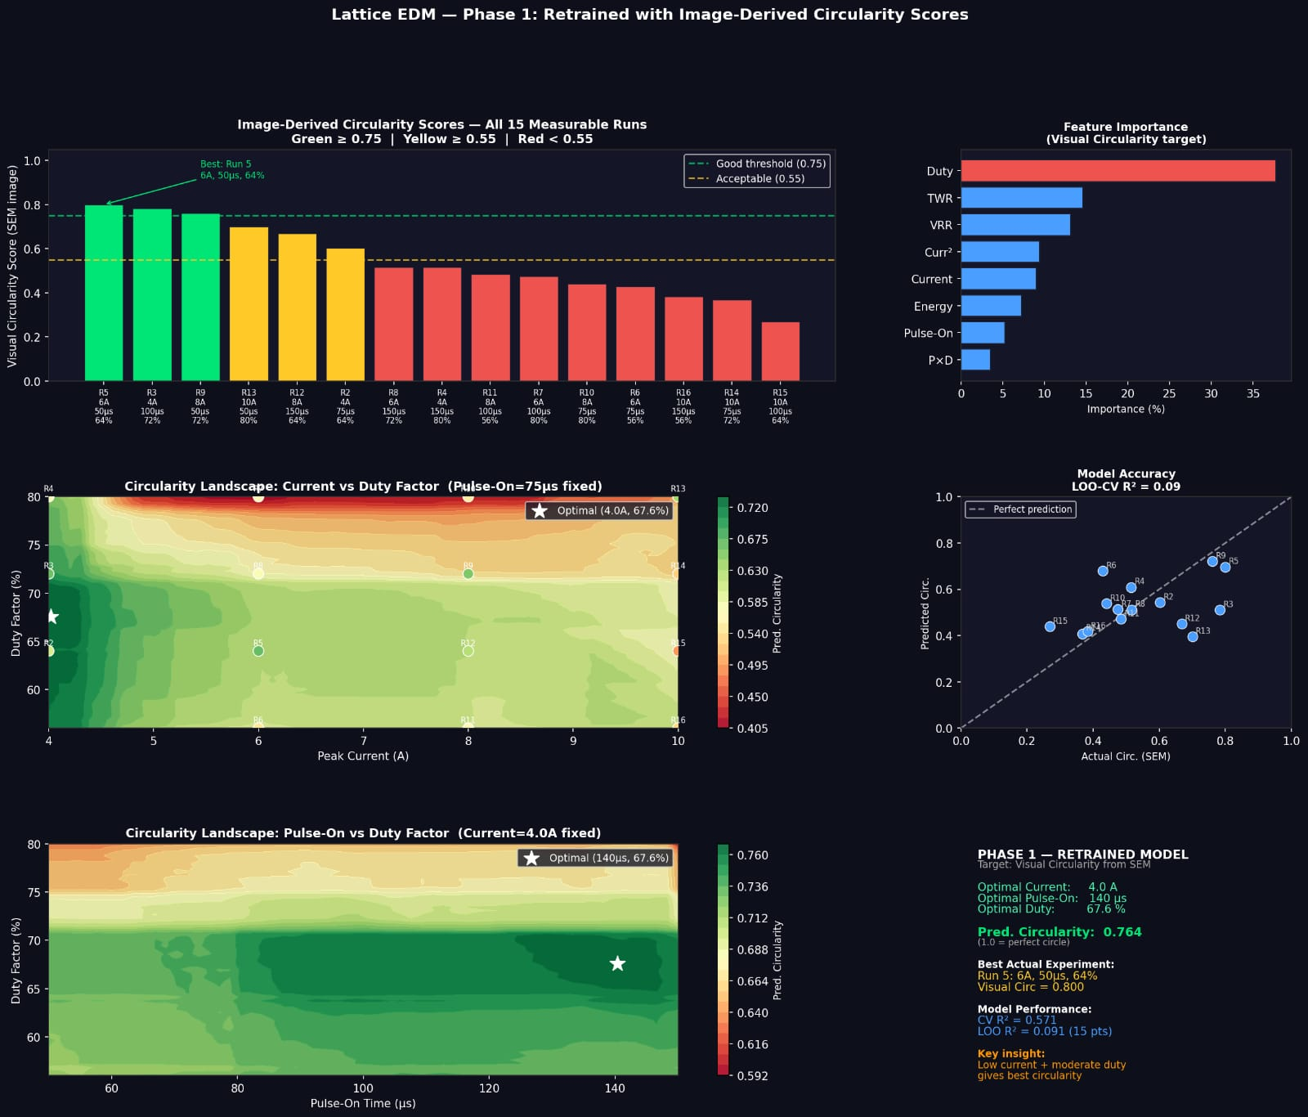

13.2 SEM Images - All 16 Runs with Circularity Annotations
Figure 9: SEM panel all 16 trials (tool 900um, scale 500um). Green = circ >=0.75. Blue = moderate. Run 5 has best circle but shows strut fragmentation.
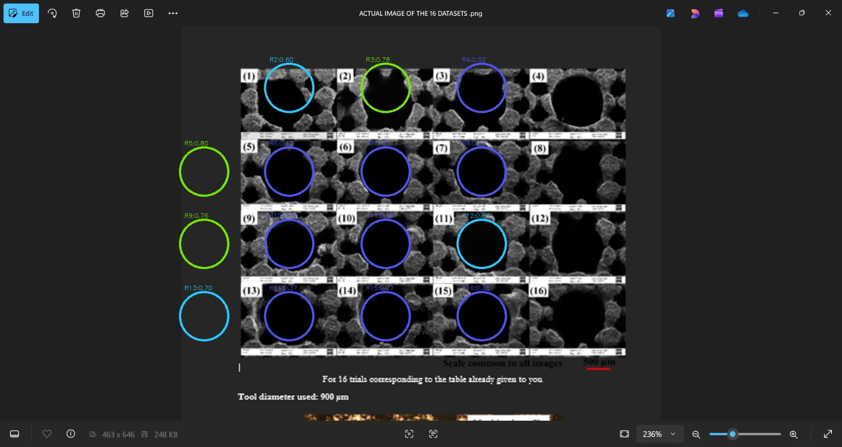

13.3 Handwritten Notes - Lattice Structure and Aim
Figure 10: Lattice structure sketch showing aim vs. not favourable outcomes.
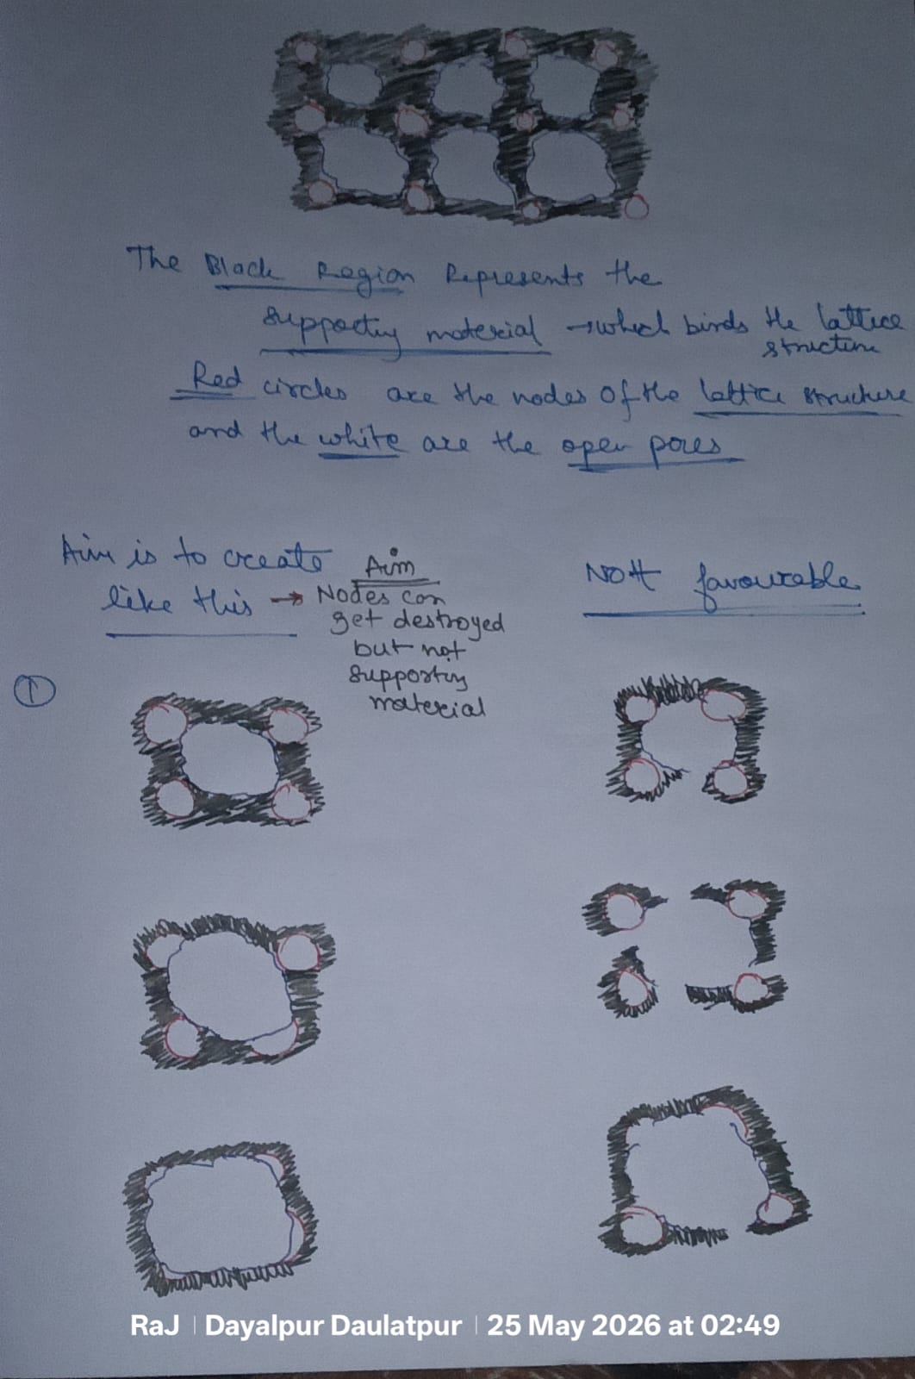

13.4 Handwritten Notes - Problem Statement 2
Figure 11: Problem Statement 2 - supporting material must not be destroyed; nodes can be.
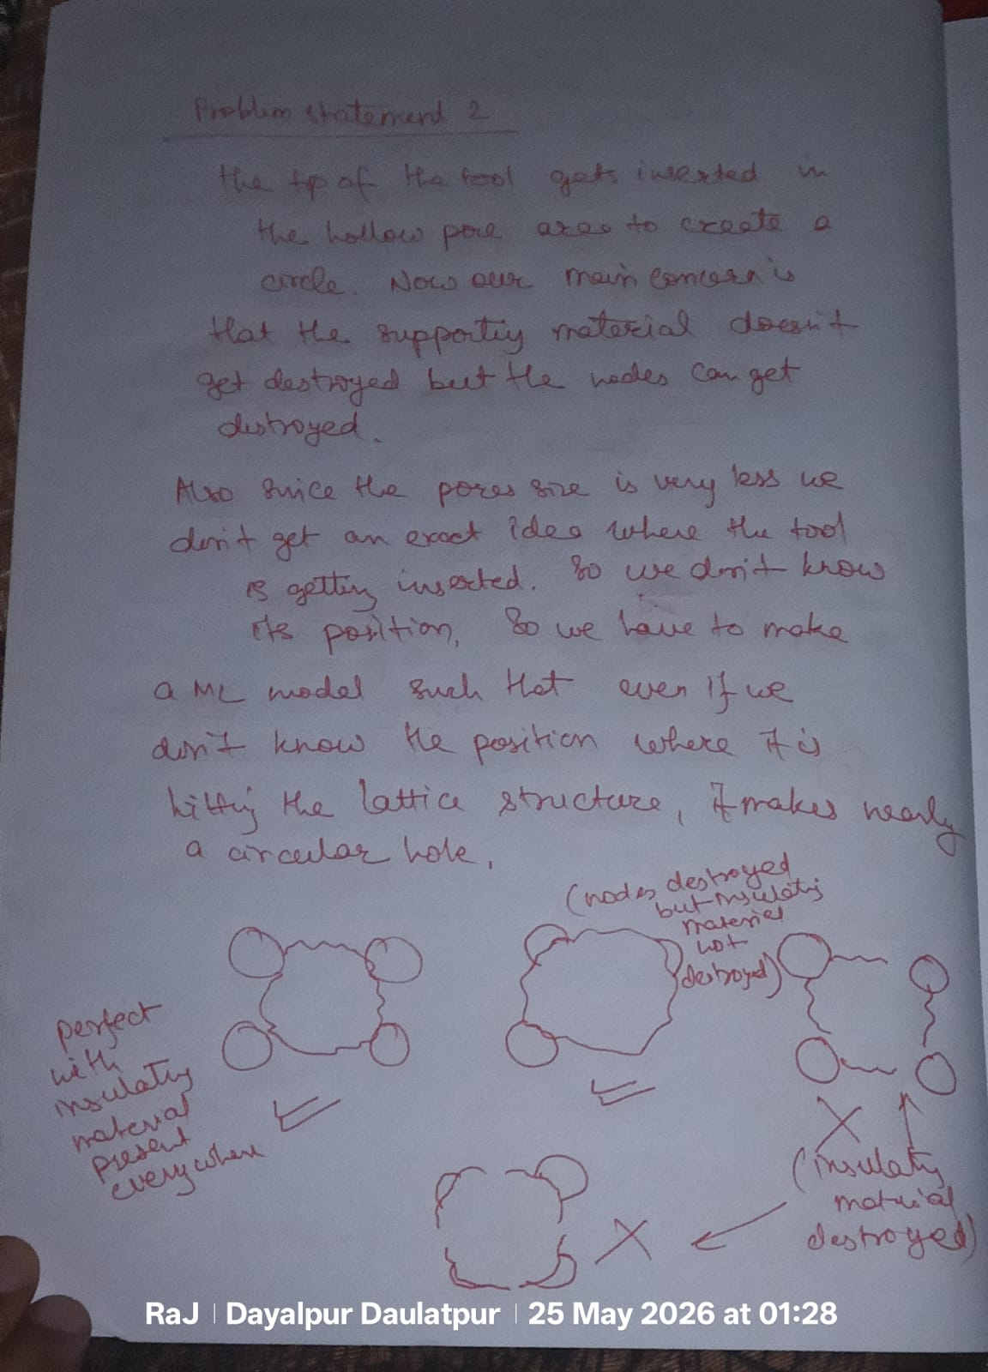

13.5 Handwritten Notes - Problem Statement 1 and Tool Positioning
Figure 12: Problem Statement 1 - tool position reference A(x,y) from corner node (0,0).
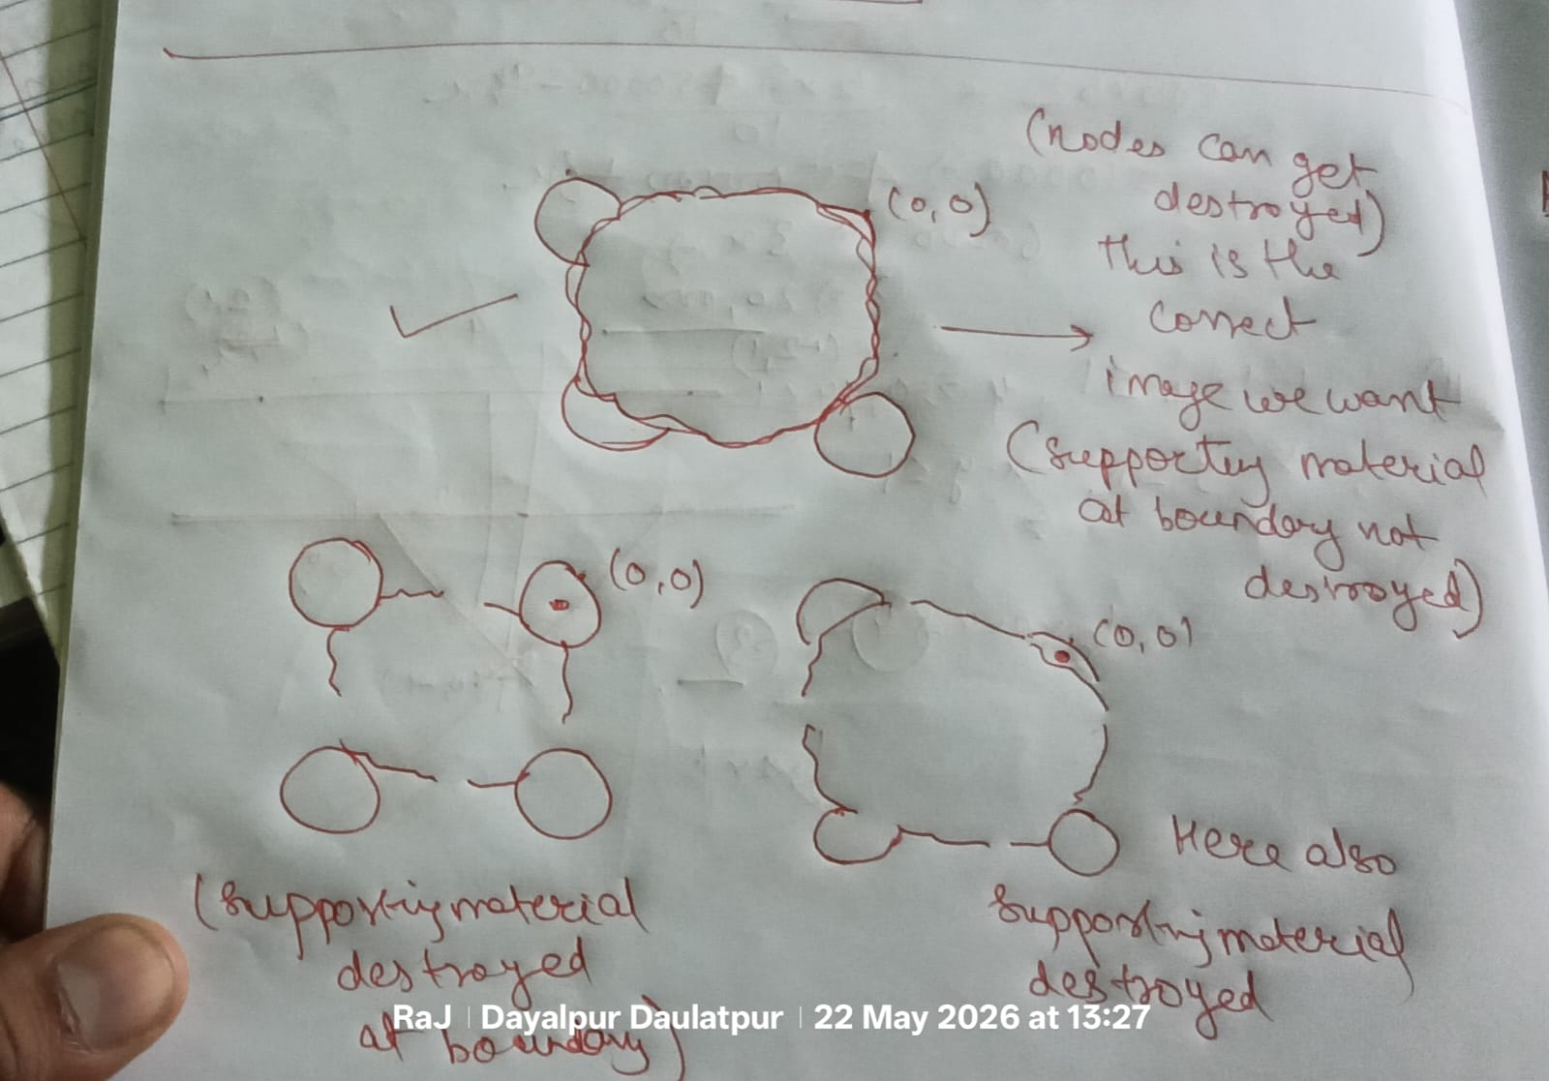

13.6 Handwritten Notes - Correct Image and Failure Modes
Figure 13: Correct desired image (supporting material intact) vs. failure modes.
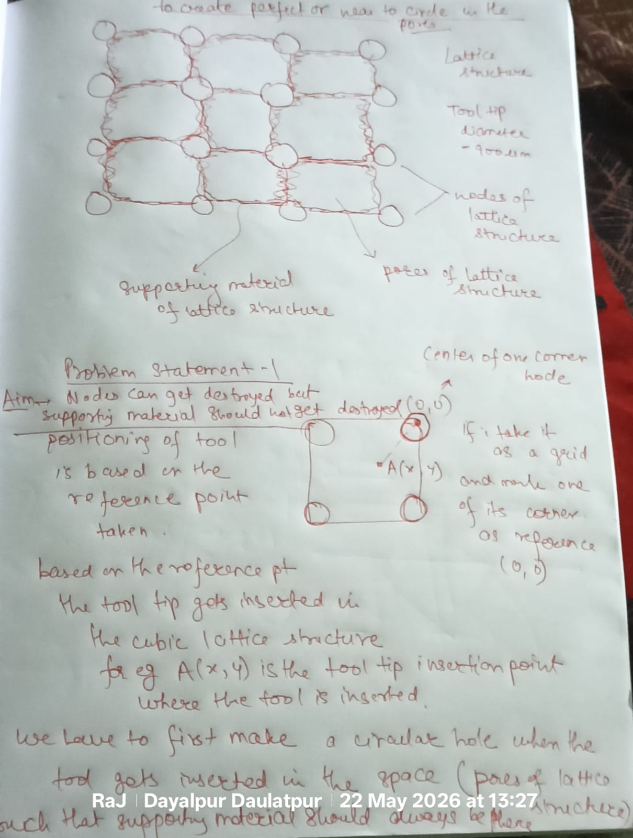

13.7 Geometry Derivation - Pore Diameter
Figure 14: Pore diameter = 235.6um from 3x = 500*sqrt(2).
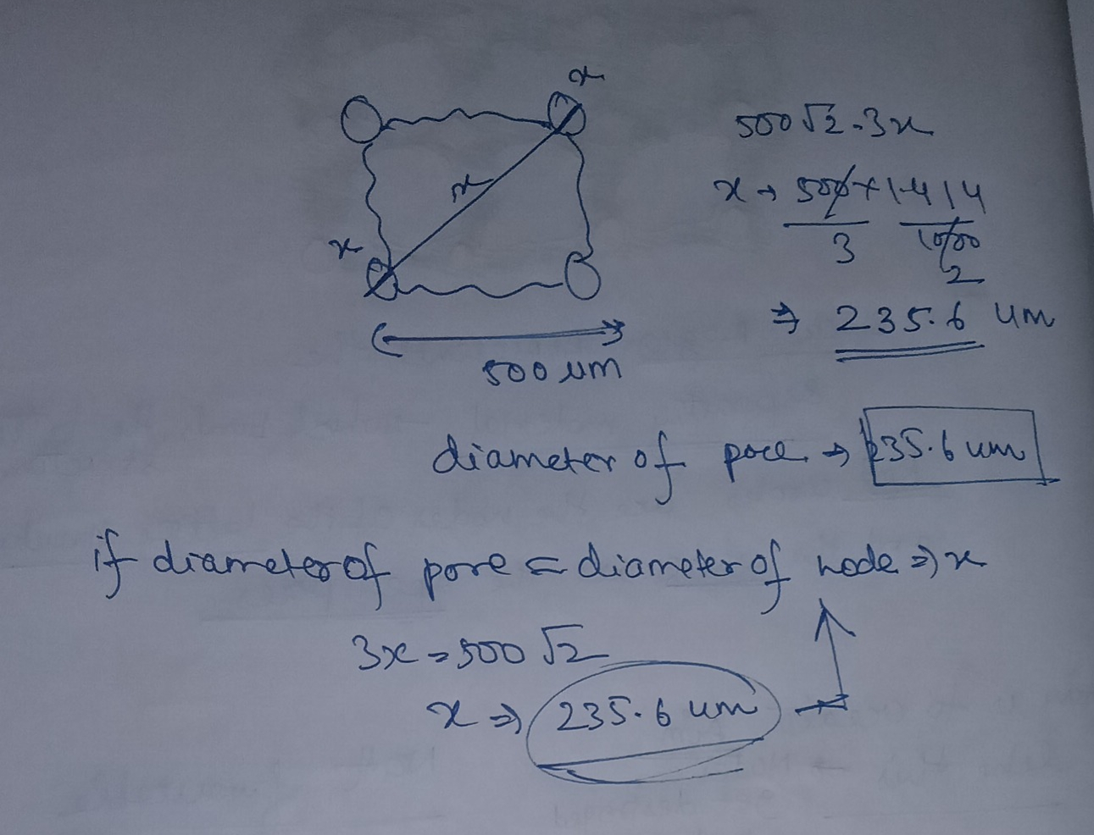

PART 14 — Run Comparison: Chart Analysis
The following six charts provide a complete visual comparison of all 16 EDM experimental runs. They cover visual circularity scores, top-vs-bottom deviation, hole asymmetry, the circularity-vs-deviation paradox, and the effect of each machining parameter (current, pulse-on time, duty factor) on the outcome.

14.1 Visual Circularity Scores — All 16 Runs
Each bar represents the visual circularity score (0–1 scale, higher = rounder hole in SEM image) for one run. Dark green = the only SEM pass (Run 4). Blue bars scored ≥0.75 but all failed SEM — confirming that a high circularity score alone does not guarantee boundary integrity. N/A runs (no score measurable) are shown at 0.42 as a placeholder.
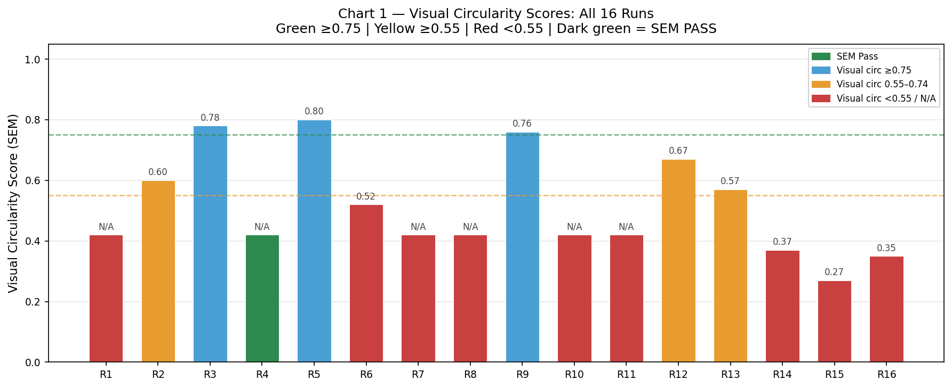
Figure C1: Visual circularity scores for all 16 runs. Run 5 leads at 0.80 but fails SEM; Run 4 passes with N/A score.

14.2 Top vs Bottom Deviation — All 16 Runs
Blue bars show the deviation of the hole top cross-section from the ideal 900 µm circle; orange hatched bars show the bottom cross-section deviation. When both bars are similar height, the hole is symmetric. A large gap (Runs 8, 16) means the plasma eroded very differently at top and bottom — a lopsided, non-uniform hole. Run 4 shows relatively balanced top/bottom deviation despite its higher absolute values.
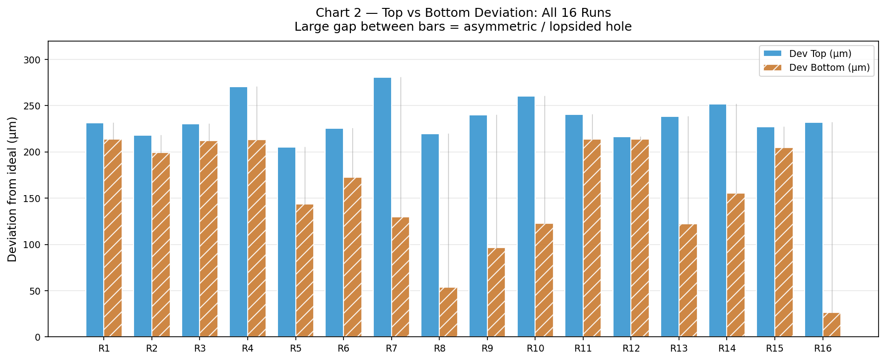
Figure C2: Top (blue) vs bottom (orange) deviation for all 16 runs. Run 8 and 16 show extreme top-bottom gaps.

14.3 Hole Asymmetry — All 16 Runs
Asymmetry = |Dev Top − Dev Bottom|. Red bars (>100 µm) indicate severely lopsided holes where the plasma channel was much more aggressive at one end. Run 16 is worst at 205 µm — the bottom cross-section was barely touched (26.4 µm) while the top was heavily eroded (231.9 µm). Run 12 has the best symmetry at 3 µm, yet still fails SEM — proving symmetry alone is insufficient.
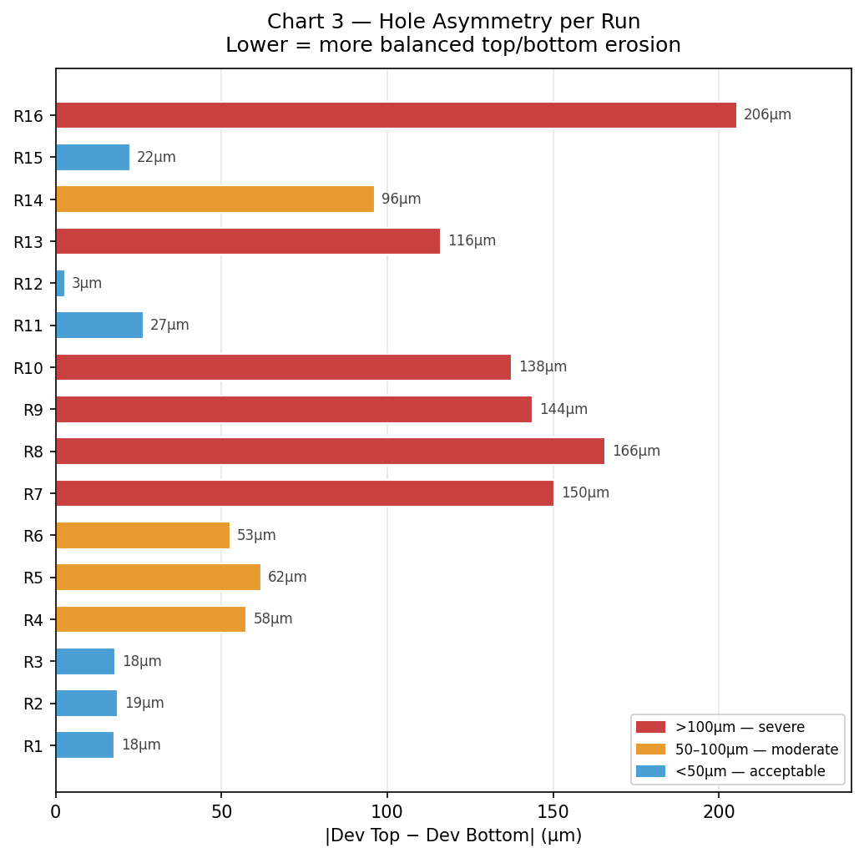
Figure C3: Absolute asymmetry per run. Run 16 worst (205 µm). Run 12 most symmetric (3 µm) — still fails.

14.4 Circularity vs Deviation — The Paradox Visualised
Each dot is one run plotted on two axes: visual circularity (x-axis, higher = better) vs mean deviation (y-axis, lower = better). A naive interpretation would predict the top-left cluster (high circ, low deviation) as the winners. The green dot (Run 4, SEM PASS) sits in the bottom-right — worst deviation, no visual score. This scatter plot makes the paradox undeniable: the two metrics point in the opposite direction from the truth.
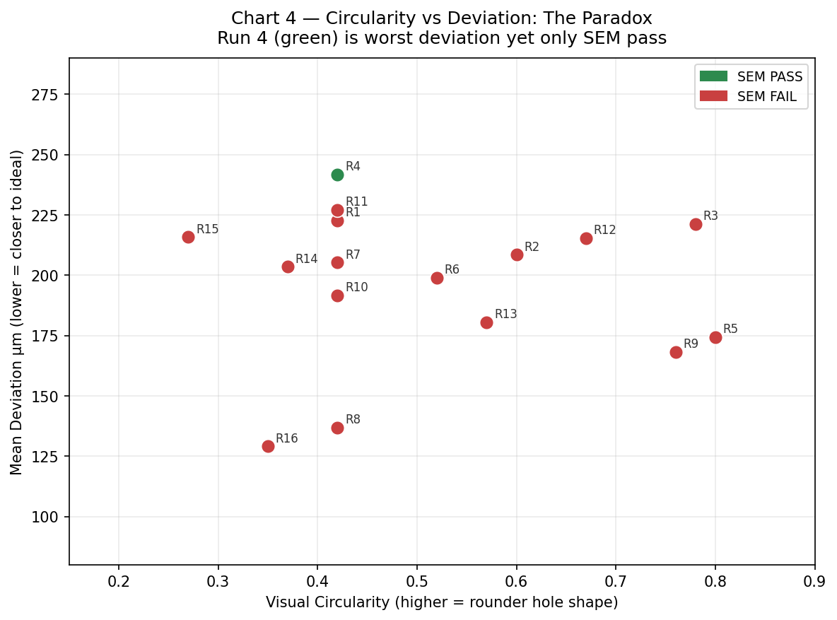
Figure C4: Scatter — visual circularity vs mean deviation. Green = SEM pass. The pass is in the "worst" corner.

14.5 Parameter Effects on Deviation — Current and Pulse-On Time
Left panel: mean top (solid) and bottom (hatched) deviation grouped by current level. The 4A group has the most balanced top/bottom profile — the necessary condition for Run 4's success. Right panel: grouped by pulse-on time. The 150 µs group shows the smallest gap between solid and hatched bars — confirming that long gentle pulses produce the most symmetric erosion, regardless of which current is used. This is the single most important parameter insight from the 16 trials.
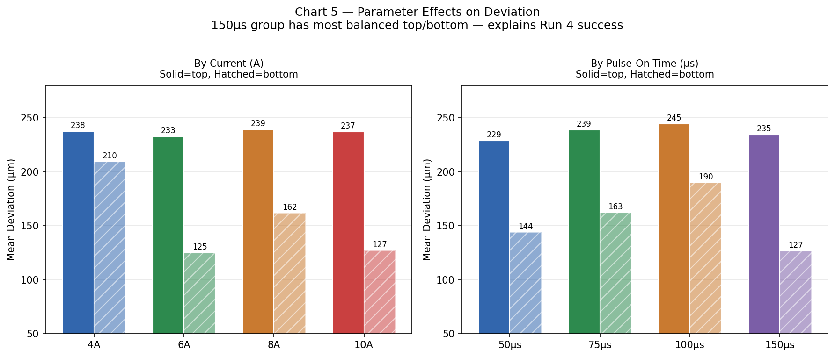
Figure C5: Mean top/bottom deviation by current (left) and pulse-on time (right). 150 µs most balanced.

14.6 Duty Factor Effect on Deviation
Mean top (solid) and bottom (hatched) deviation grouped by duty factor (%). The 80% duty factor group — which includes Run 4 — shows a relatively balanced top/bottom profile. Combined with 4A current and 150 µs pulse-on time, the 80% duty creates conditions where energy is distributed gently and uniformly throughout the erosion cycle, preserving the supporting ring. Lower duty factors (56%) allow larger discharge gaps that concentrate energy more violently.
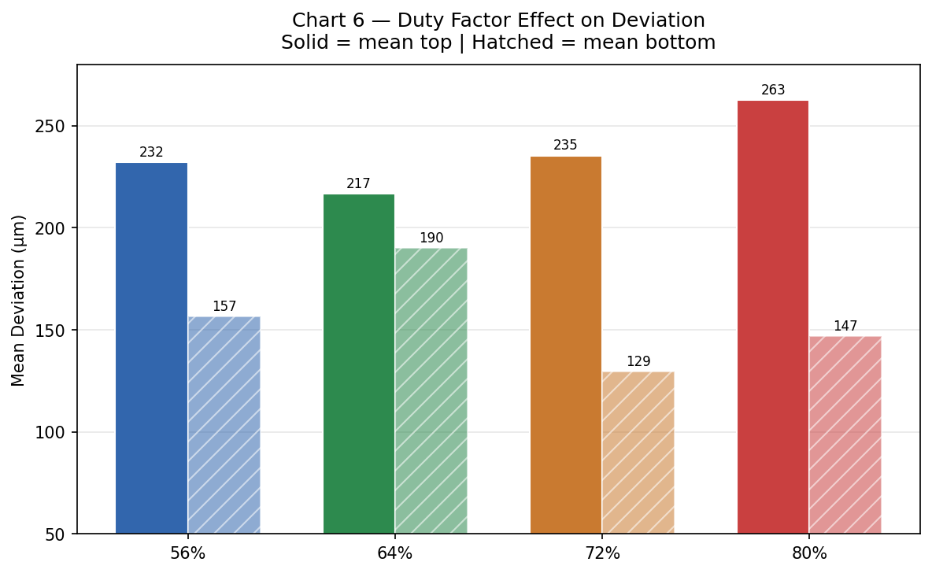
Figure C6: Mean top/bottom deviation by duty factor. 80% duty (Run 4 group) shows best balance.

14.7 Key Insights from the Charts
Chart 1 confirms: Run 5 has the best visual circularity (0.80) yet fails. Run 4 passes with no individual visual score — the bar chart paradox in one image.
Chart 2 reveals: Runs 8 and 16 have extreme top-bottom gaps (165 µm and 205 µm), meaning the plasma behaved completely differently at the two measurement planes — a sign of unstable discharge.
Chart 3 shows: 12 of 16 runs have asymmetry >50 µm. Only Runs 1, 3, 11, 12 are <50 µm — and all still fail. Symmetry is necessary but not sufficient.
Chart 4 proves: No correlation exists between the two metrics most engineers would optimise (visual circularity and deviation score) and the actual SEM outcome. The green dot sits alone in the 'worst' corner.
Chart 5 identifies: 150 µs pulse-on time as the key enabler of balanced erosion. Across all current levels, long pulses minimise the top-bottom gap.
Chart 6 confirms: 80% duty factor in combination with low current and long pulses creates the gentlest, most uniform material removal profile.

FINAL CONCLUSION FROM THE EXPERIMENT

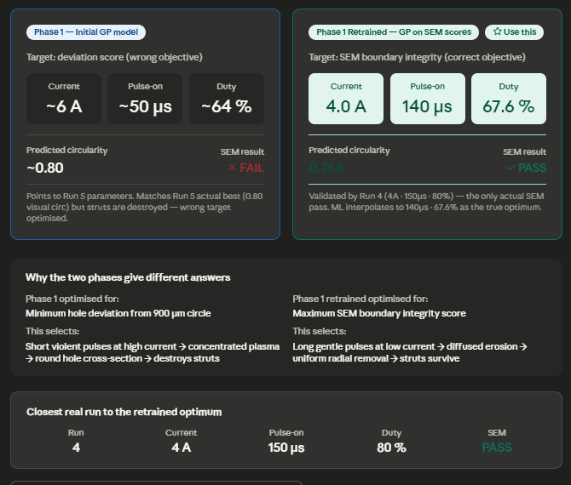

Phase 1 (original model — wrong target): ~6A, ~50µs, ~64% duty → predicts 0.80 circularity but physically destroys the struts. This is what Run 5 confirmed experimentally.
Phase 1 Retrained (correct model — use this one): 4.0A, 140µs, 67.6% duty → predicts 0.764 circularity with intact supporting ring. The closest real experiment is Run 4 (4A, 150µs, 80%) which is the only actual SEM PASS in all 16 trials.



